**Application overview:**

This application allows users to archive records from any custom or standard objects and allows for unarchiving the records. It also provides a way to visualize the amount of data archived segregated by the object Name using a dashboard.

Archiving is done by selecting a parent object and running a batch by providing appropriate filters. Once the batch is submitted for parent, we can run the batch for the child object records and the 2nd level of child objects.

Upto 2 levels of child object records can be traversed and archived.

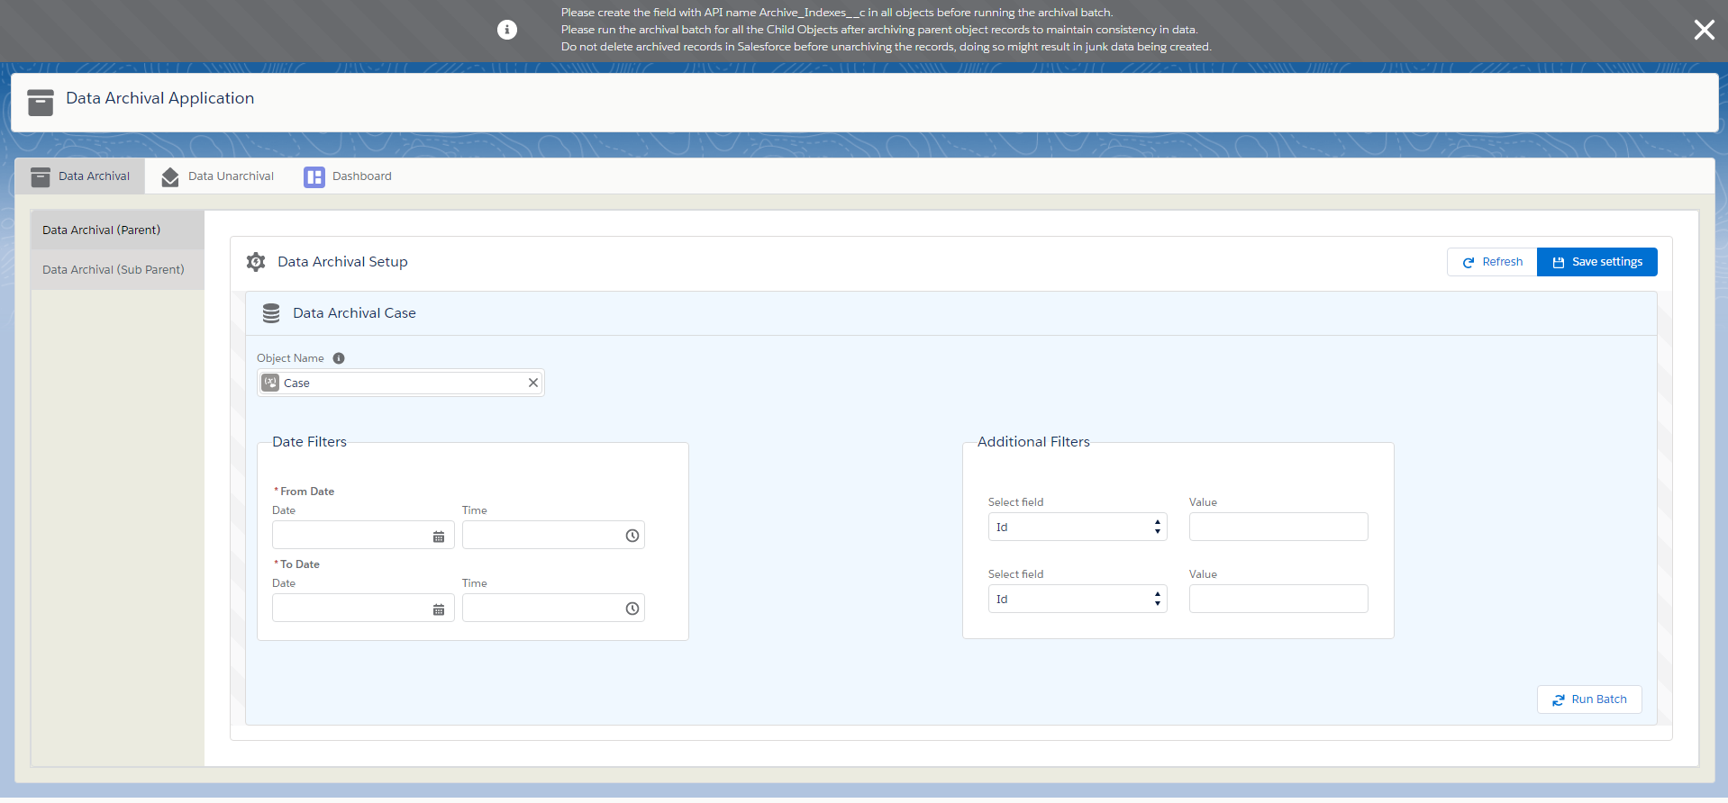

**Initial Setup:**

During the Initial start of application, we will see a button Initial setup. Once clicked it will do the necessary setup for archival and dashboard and then we can start using the application.



**Tab 1 - Data Archival Tab:**

Select an object and provide date filters and if required 2 additional field filters and save settings.

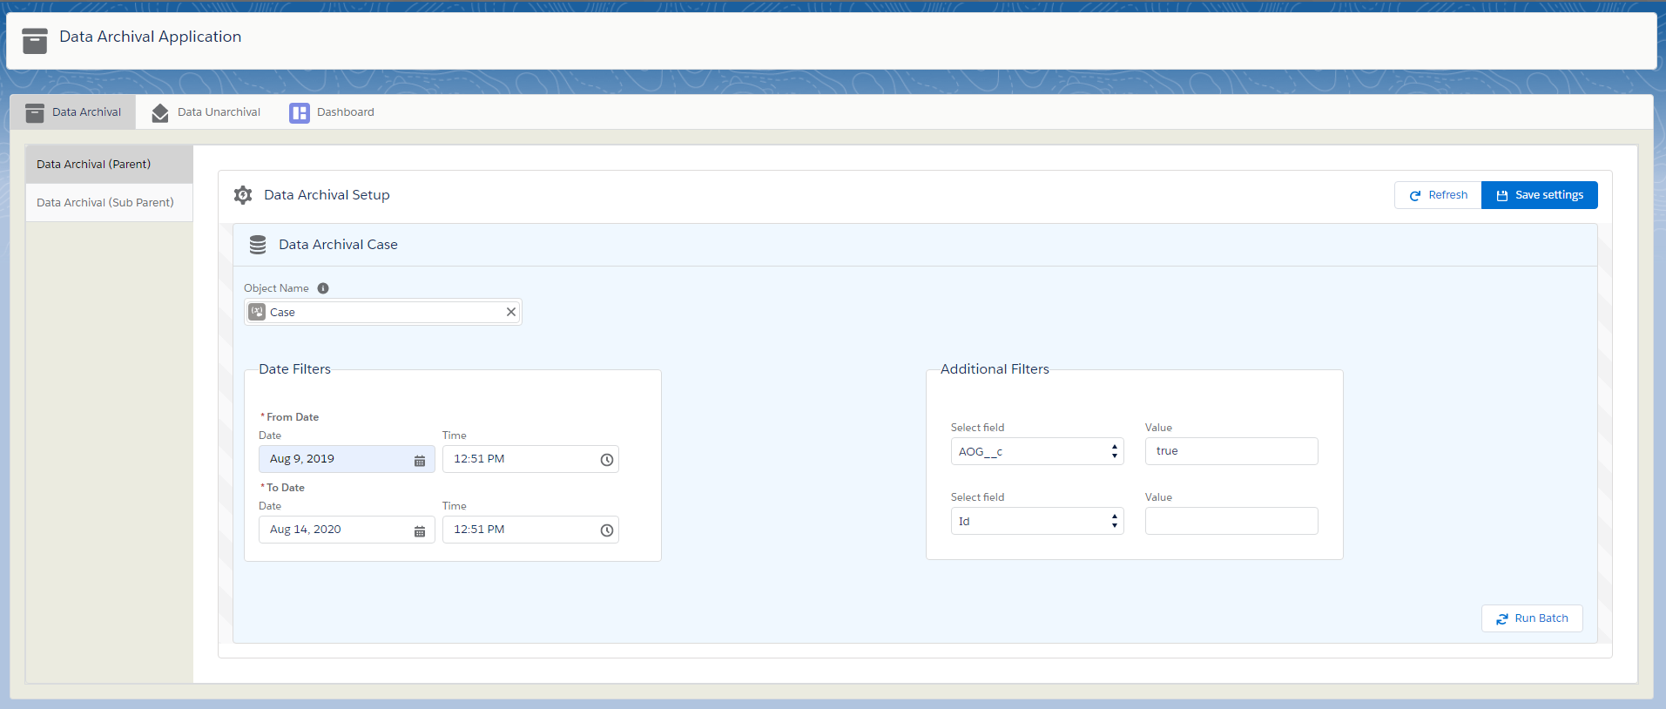

Once the settings are saved the child objects of the selected parent will be shown below the setup section. The user can run the batch for the parent object first and then the access to running child object batches are enabled once it is completed. Refresh button can be used to refresh the statuses of each object batch. After archival the archived records will have blank values and any text area field values will be added to the record as an attachment.

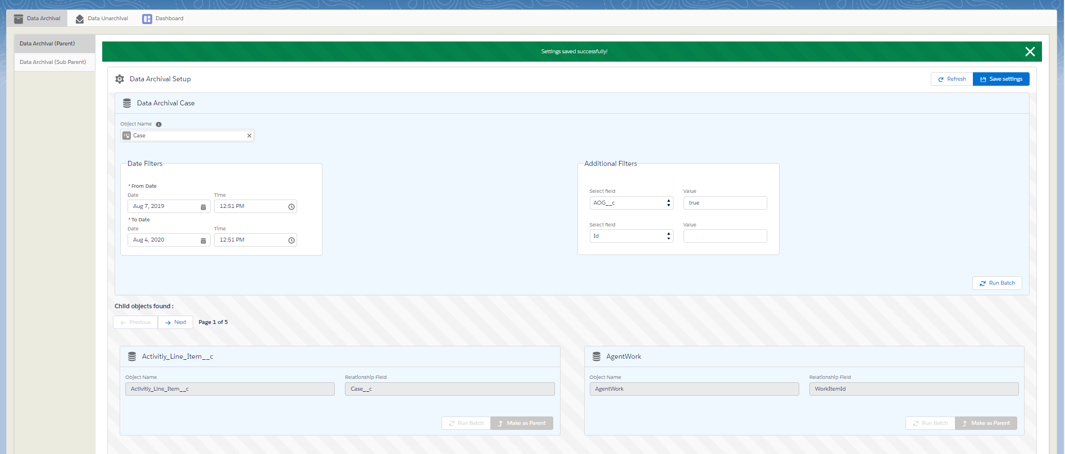

Once the batch is run for parent object, we can run the batch for child objects similarly and make the child object as the new parent to run the archival batch for 2nd level child objects.

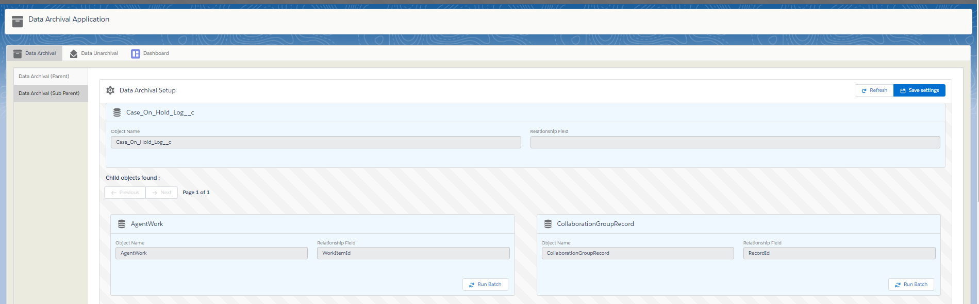

**Tab 2 – Data Unarchival**

This tab allows users to select the object by API name and select the fields that need to be displayed in the table.

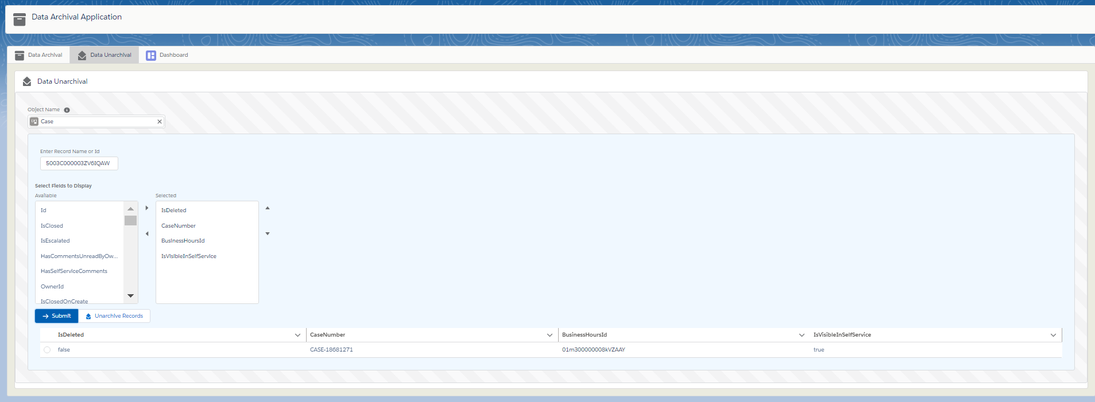

Once submitted the record is displayed in the table. Users can select the record and click on unarchive Record if they want to retrieve the record data into the actual record.

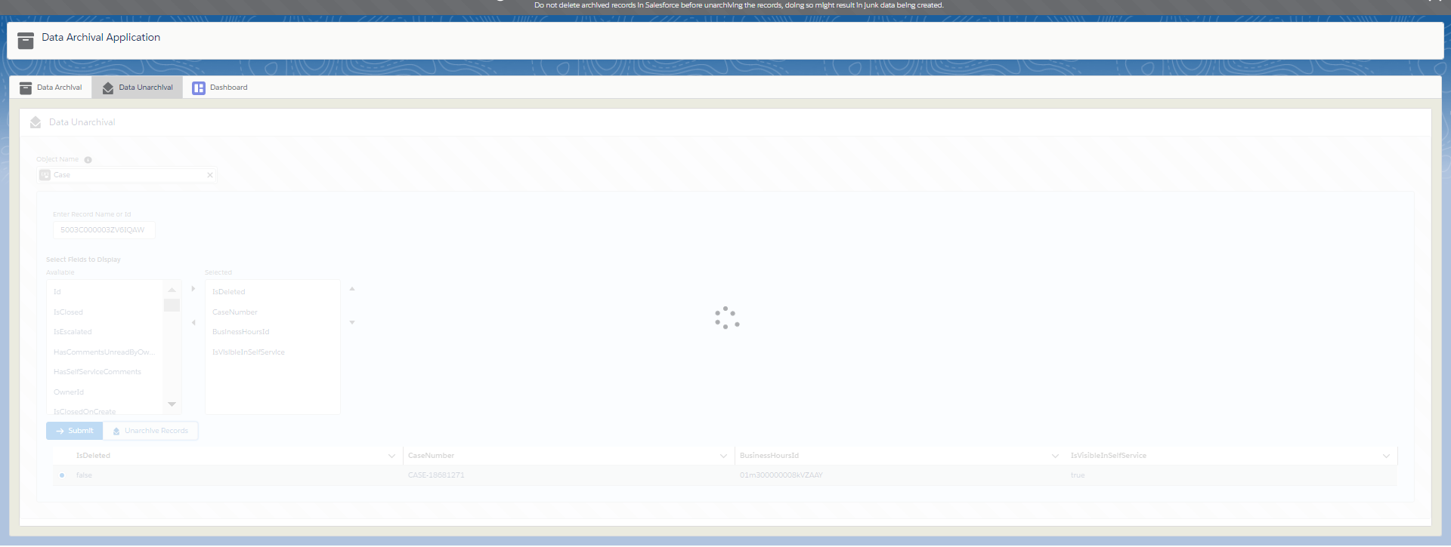

**Tab 3 – Archival Dashboard**

This is a dashboard that shows a pie chart which shows the percentage distribution of archived records of each object in the archived dataset.

There is a bar graph and a report which shows the appropriate count of archived records of each object.

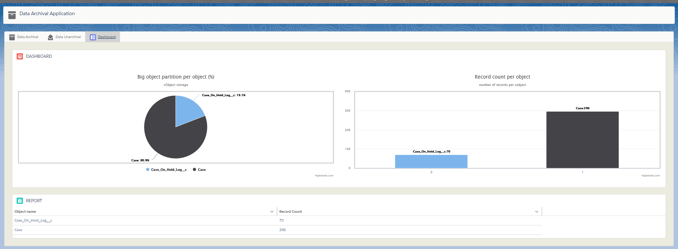

**Post Installation steps:**

1. Create a record in archival_settings__c and data_archival_settings__c with

Name=’currentIndex’

Indexvalue__c=’1’

Record_id__c= the record id for the same record after saving.

1. A field with api name ‘**Archive_indexes__c’** must be created in the object which we will archive.
2. A field with api name ‘**Email_Archive_indexes__c’** must be created in the case object where we store the email archived indexes.
3. A header record with indexvalue__c=’0’ and datetimestampindex__c=’HeaderIndex’ must be created in both dataArchive__b and emailArchive__b big objects.
4. For dataarchive__b header record:

recordjson1__c=a json string of all the object names, record count where the record count of all objects is initialized to 0.

Ex: {“Account”:0, ”Contact”:0,..}